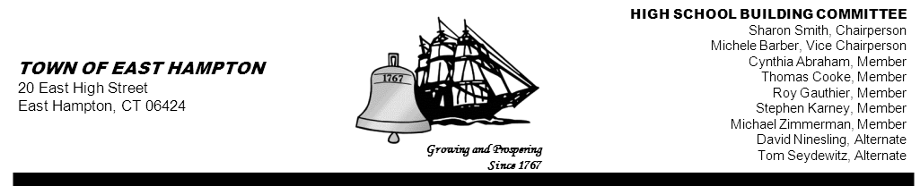

HIGH SCHOOL—ADDITION & RENOVATE-AS-NEW
HIGH SCHOOL BUILDING COMMITTEE MEETING
Main St., East Hampton, CT 06424
East Hampton Public Library Community Room
Thursday, March 5th, 2015, 5:30 p.m.
PRESENT AT MEETING
Committee Members: Sharon Smith, Chairperson; Michele Barber, Vice-Chairperson; Roy Gauthier, Michael Zimmerman, Tom Seydewitz, Cynthia Abraham, Stephen Karney, and David Ninesling.
Member(s) Absent: Thomas Cooke
Also Present: Michael Maniscalco, Town Manager; William Marshall, BOE Representative; Chris Cykley; CREC, George Pfaffenbach, Town Council Member; Glenn Gollenberg, SLAM.

- David Ninesling was accepted as a voting member.
- Public Remarks:
- Bill Marshall, BOE liaison, informed the committee of communication with Representative Ziobron concerning the education bill and the “notwithstanding” language. To date the bill has not been discussed at the capital, however, once she has the bill # she will provide us with information for letters of support. He also iterated the BOE supports and appreciates the work the Building Committee has accomplished so far.
- Approval of RFP for OPM (Owners Project Manager):
- Committee reviewed and discussed the RFP for OPM. Michael Maniscalco answered committee questions concerning the start date and some minor changes to the contract language. Glenn Gollenberg suggested separating the audit responsibilities. A discussion on timeline of the contract/audit ensued.
- Michael Maniscalco reminded the committee that ultimately the committee will make a decision to contract with an OPM based upon both the lowest bid and the bidder with the highest qualifications.
- Cynthia Abraham made a motion to approve the RFP, with minor language amendments, for OPM services. The motion was seconded by Stephen Karney. All were in favor, the motion carried 7-0.
- Approval of Quarterly Report #7:
- Michael Zimmerman made a motion to approve with addition of the renovate as new information. The motion was seconded by Roy Gauthier. All were favor, the motion carried 7-0.
- Public Remarks: None

- Next Meeting: March 12th, 5:30 PM. Interviews for the OPM will take place on March 25th.

- Motion to Adjourn: Roy Gauthier made a motion to adjourn at 6:05 PM. The motion was seconded by Stephen Karney. All were in favor, the motion carried 7-0.

